Vignesh Venktesan

**F U L L S T A C K D E V E L O P E R**

# P E R S O N A L I N F O

Full Stack Developer with skills in Java and PHP, experienced in creating and building strong web applications. Passionate about continuous learning and eager to leverage new technologies to drive both personal and organizational growth. Proven ability to collaborate effectively within teams and deliver high-quality results in fast-paced environments.

# C O N T A C T E D U C A T I O N

+91 8610400046

[vigneshvenky210@gmail.com](mailto:vigneshvenky210@gmail.com) Tindivanam , Villupuram

**Jeppiaar SRR Engineering College**

*University name*

**St Joseph of cluny mat hr sec school**

*School Name*

**2018 - 2022**

**2004 - 2018**

# S K I L L S

PHP HTML

JS, Bootstrap

# E X P E R I E N C E

**Neuralarc Global Private Limted**

*Full stack Development*

**Jan-2023-Present**

MySQL

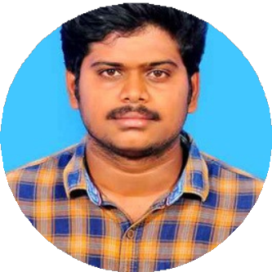

Codelgniter Framework CSS

# C E R T I F I C A T I O N

🎓 Became a certified Full Stack Developer, enhancing my proficiency in various technologies.

💻 Gained expertise in Java, HTML, CSS, JavaScript, and various frameworks.

🔧 Acquired hands-on experience that has been invaluable in my professional development.

📊 Represented the team’s services and offerings by delivering presentations to other teams 5+ times a month, effectively communicating project outcomes.

🔍 Worked with the R&D team to identify critical emerging technologies and conducted strategic research to support innovation.

📈 Continuously enhanced my programming skills and logical thinking through hands-on experience and ongoing projects within the company.

🗄 Gained extensive knowledge in database management, enabling efficient data storage and retrieval for various applications.

💻 Acquired proficiency in programming languages such as Java and PHP, contributing to diverse projects and enhancing overall development capabilities.

🔗 Proficient in connecting front-end and back-end technologies, ensuring seamless integration and functionality in web applications.